TABLE OF CONTENTS

S.No. | Module No | Page No.
1 | Module 2

Data Structures & Algorithms:

- Analysis of Algorithms
- Data Structure: Organizes data efficiently.
- Algorithm: Step-by-step procedure to solve a problem.
- Time Complexity: Execution time of an algorithm.
- Space Complexity: Memory used by an algorithm.
- Asymptotic Notations
- O() → Worst Case
- Ω() → Best Case
- Θ() → Average Case
3.) Arrays
- Stores elements in contiguous memory.
- Fast random access.
Operations
- Traversal → O(n)
- Search → O(n)
- Insert → O(n)
- Delete → O(n)
4. Linked List
Types
- Singly Linked List
- Circular Singly Linked List
- Doubly Linked List
- Circular Doubly Linked List

Operations
- Insert → O(1)
- Search → O(n)
- Traverse → O(n)
- Delete → O(n)
5. Searching Algorithms
Linear Search:
- Checks elements one by one.
- Time Complexity: O(n)
Binary Search:
- Works on sorted arrays.
- Time Complexity: O(log n)
HANDS ON:
Exercise 2: E-commerce Platform Search Function
Scenario:
You are working on the search functionality of an e-commerce platform. The search needs to be optimized for fast performance.
Steps:
- Understand Asymptotic Notation:
  - Explain Big O notation and how it helps in analyzing algorithms.
  - Describe the best, average, and worst-case scenarios for search operations.
- Setup:
  - Create a class Product with attributes for searching, such as productId, productName, and category.
- Implementation:
  - Implement linear search and binary search algorithms.
  - Store products in an array for linear search and a sorted array for binary search.
- Analysis:
  - Compare the time complexity of linear and binary search algorithms.
  - Discuss which algorithm is more suitable for your platform and why.
IMPLEMENTATION:(LINEAR SEARCH)
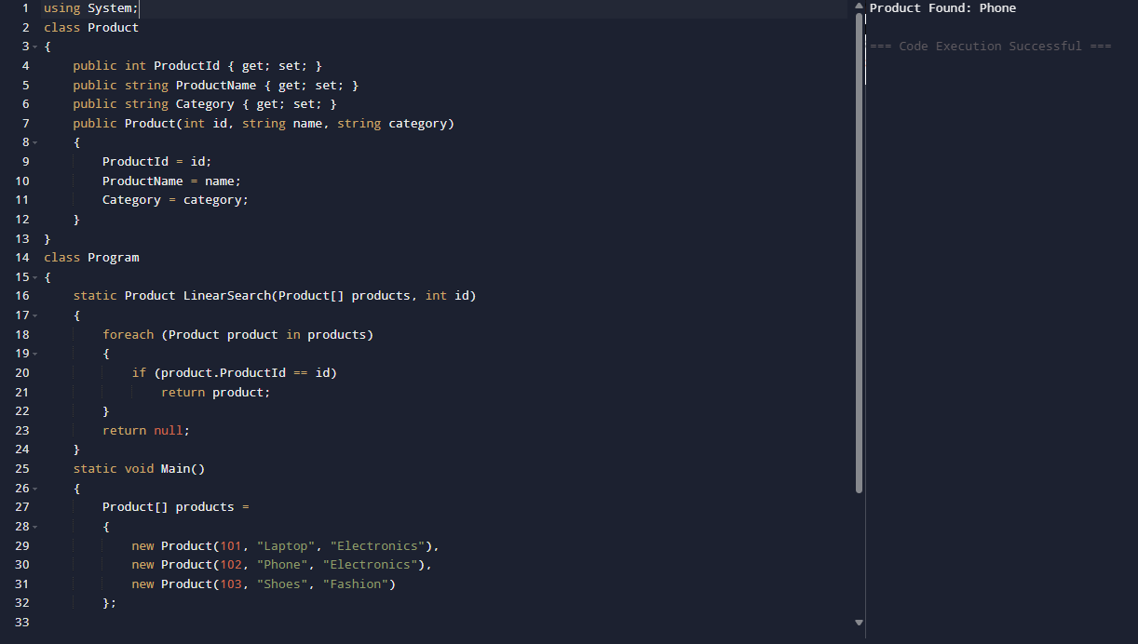

IMPLEMENTATION:(BINARY SEARCH)
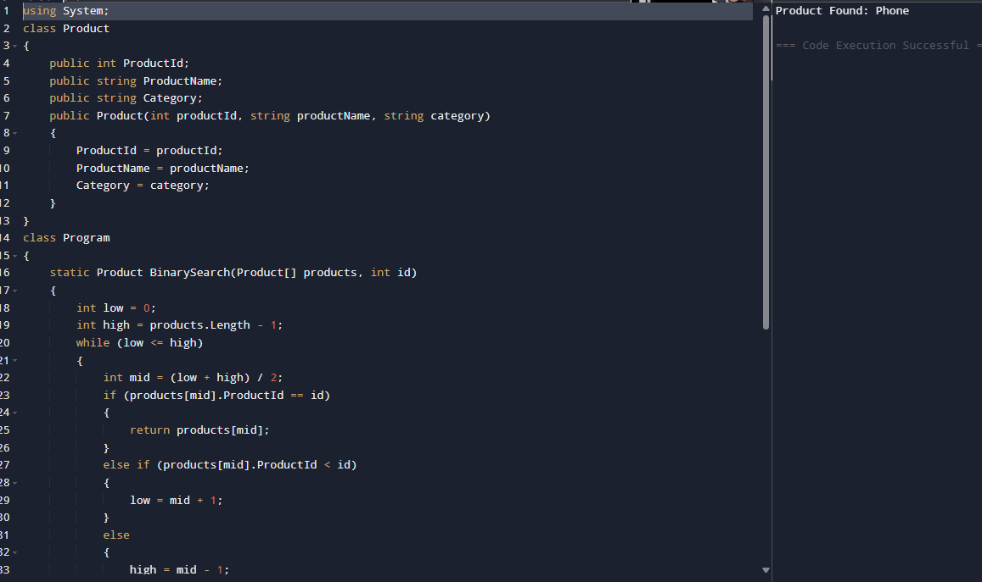

Exercise 7: Financial Forecasting
Scenario:
You are developing a financial forecasting tool that predicts future values based on past data.
Steps:
- Understand Recursive Algorithms:
  - Explain the concept of recursion and how it can simplify certain problems.
- Setup:
  - Create a method to calculate the future value using a recursive approach.
- Implementation:
  - Implement a recursive algorithm to predict future values based on past growth rates.
- Analysis:
  - Discuss the time complexity of your recursive algorithm.
  - Explain how to optimize the recursive solution to avoid excessive computation.

HANDS ON:

1. Recursion:
Recursion is a technique where a method calls itself until a base condition is reached.
Example:
factorial(n) = n * factorial(n-1)

2. Financial Forecasting Logic:
Suppose:
- Current Value = 1000
- Growth Rate = 10%
- Years = 3
Then:
Year 1 = 1000 × 1.10 = 1100
Year 2 = 1100 × 1.10 = 1210
Year 3 = 1210 × 1.10 = 1331

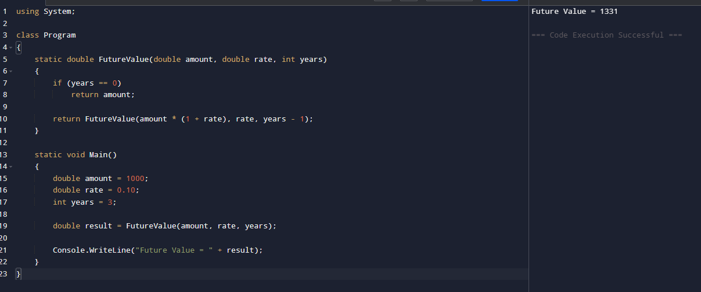

Analysis:

Time Complexity
Each recursive call reduces years by 1.
T(n) = T(n-1) + O(1)
Therefore:
Time Complexity = O(n)
where n = number of years

Space Complexity
Recursive call stack:
O(n)

Optimization:
Instead of recursion, we can use:
double futureValue =
presentValue * Math.Pow(1 + growthRate, years);
Formula:
Future Value = Present Value × (1 + Growth Rate)^Years
This avoids many recursive calls and reduces overhead.
*Time Complexity*: O(1)

QUIZ COMPLETION:
